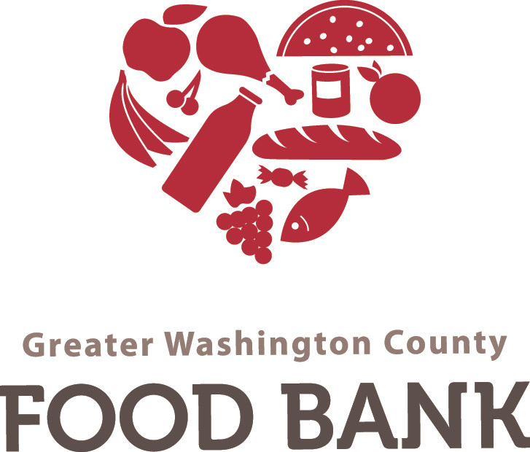

Max Dunaevschi, Blythe Weng, Shalini Rao

February 20, 2020

# 

# 

# 

# 

# **Community Partner Background**

**About the Organization**

*Give an overview of the organization, ministry, authority, business, school, nonprofit, or NGO you are working with. Include its* ***location****, relationship to the community or market, its* ***mission*** */* ***purpose*** */* ***goals****, major program or business areas.*

Greater Washington County Food Bank is a 501(c)3 community service non-profit that provides groceries / nutrition information to food insecure people in Washington county (30 min south of Pittsburgh). The food bank consists of 21 employees, but anyone can register as a volunteer to help hand out food. The missionof Greater Washington County Food Bank is:

*Form lasting solutions to hunger insecurity through effective food distribution systems; to educate and empower the needy in seeking positive lifestyle changes; and, to create awareness through individual and community partnerships.*

GWCFB’s main goal is to educate citizens on how to become more food secure. Prior to COVID-19, the food bank provided food and other necessities to low-income patrons, but they have now made exceptions for service workers who are no longer able to get work hours. They provide a mix of boxed items, canned goods, and health products along with meats, produce, and bakery items, resulting in the administering of 40 - 50k pounds of food each week. GWCFB has a well established distribution system to ensure low-income families and community members still have access to healthy and affordable food. The main distribution program is Truck to Trunk, a drive-thru system where pre-registered clients come and pick up their food.

## **Programs**

*Describe the major programs, activities, product lines, or services of the organization. Describe these activities in general, how the activities support the mission of the organization, and briefly how technology is used.*

The Greater Washington County Food Bank’s main program focuses on providing groceries and nutrition to those who are food insecure in the Washington County area. The food bank is based on a non-traditional program which incorporates a range of community outreach programs focused on educating those in need on how to become less food insecure. The organization also makes sure they only distribute high quality and healthy food to those in need, following their goal to encourage people to focus on good nutrition. Because of the COVID 19 pandemic, the food bank is focusing on ensuring a safe environment for those who are picking up food, adapting a truck to trunk model that allows for safe, no-contact food pickups.

Aside from its main food bank program, the Greater Washington County Food Bank also offers a healthy habits training center aimed to help those who are food insecure learn about good nutrition and develop healthy eating habits. Prior to the COVID 19 pandemic, the organization also partnered with various other organizations to hold trainings for those in need. These classes included homesteading groups, beekeeping groups, and other structured class settings.

Lastly, GWCFB has multiple hydroponic units and hires interns to learn about and work on these units in order to grow produce locally. The organization then sells this produce and uses the money earned to buy wholesale non perishable items, allowing them to have more food to distribute that can be stored for a longer period of time.

## **Staff**

*Describe the staff working at the organization. Include an overview of the whole organization, but focus on those you will be working with most directly, and those who will be most impacted by your likely work there.*

The organization has a board of directors that focuses on overseeing the entire organization and the financial aspects needed to keep its programs running. Other staff members include truck drivers to deliver food to various locations, a warehouse manager that also handles IT tasks, volunteers to organize and distribute food to individuals in need, and interns that learn and grow fresh produce in hydroponic units. The GWCFB also partners with other organizations that come and teach for their various other educational programs.

The warehouse manager, Jon Schubert, is the main person responsible for interacting with information systems and is who we focus on working with most directly. He is responsible for keeping track of the amount of food and product that goes in and out of the warehouse using QuickBooks software and Microsoft excel. However, this method is inefficient and prone to human error. It requires a person to manually enter in every food package which can be extremely time consuming. Though staff is trained to use QuickBooks, they are not provided training for other more efficient software programs.

## **Information Management**

*How is information managed by the organization? What information is critical to the organization (e.g. donor information, client information, case management, orders, invoices)? How is the information managed? Is it managed electronically, via paper, or mixed? Does it have information systems to manage its critical information needs? How does information flow electronically among staff in the organization? Is information entered only once, or need it be entered repeatedly? Have they tried to automate in the past? How has that gone? How have their current databases been built? By staff? Volunteers? Interns? What are the shortcomings of their current information systems? Duplication of work? Erroneous reports? How could their operations or programs be enhanced by managing information better?*

The current system they have in place uses QuickBooks accounting software and Microsoft Excel. Each transaction (either donation or distribution) requires a series of documents for accurate reporting and to balance the inventory in QuickBooks. Their state and federal government funding mandates they keep accurate books to report back on the distribution of their donations. Depending on the source the food or donation is coming from, the distributions that result are either unrestricted or restricted to that agency’s definition of “food insecure.” Each item donated has its own item number and a letter code to indicate where it came from. This composite key is used to build inventory assemblies for each distribution based on the income guidelines for that particular distribution.

When they receive an item, they must create a purchase order and build an item number in QuickBooks to identify the incoming item. They can then receive inventory with a bill so they can “pay” the vendor. However, though GWCFB does not pay for most of the food they receive, they use a CONTRA account to balance out the transaction for valuation purposes as required by the QuickBooks software. Once they have created the bill, they can then physically receive the inventory. The customer (either a food pantry or a distribution location) is given an invoice as required by another CONTRA process, even though the customer in this case is also not paying for the commodity either. This exchange deducts the units from the total quantity in the software for goods stored in the warehouse. Since all of these transactions are inputted manually, a single misstroke of a key can create a large error in the bookkeeping.

They use a Microsoft Excel spreadsheet to create assemblies for a given distribution. They keep a count of how many of each item they have and what restrictions exist for each item. They then input the number of boxes they are aiming to make for that particular distribution and the spreadsheet calculates how many of each item need to be put into each box, allowing for specially donated items to be placed in as well. They keep tally of each box in terms of weight, so the calculations help maximize the number of items that can be placed in each box without going overweight.

The QuickBooks software they use is not meant for nonprofit transactions where no money is exchanged. The GWCFB is forced to go through multiple extraneous processes that are non-applicable to their transactions simply because QuickBooks is meant for business transactions of money for goods. It is also almost entirely manually inputted, which wastes time both for data entry and fixing errors retroactively. They also use paper pallet tags to mark each item in the warehouse. These tags have all the necessary information for that item including product ID, description, unit weight, quantity, expiration date, and restrictions. This is incredibly inefficient since it requires being physically close to the pallet to know all necessary information, risking the tag falling off and the item not having an indicator.

# **Community Partner Project Opportunity**

# **Project Opportunity**

*Given the background of your partner organization, this section should identify and describe the problems facing the organization. You should describe the problem(s), why it is important to solve, and any solutions that have been considered prior to your interactions.*

Greater Washington County Food Bank wants us to develop an inventory tracking system that will work with their existing QuickBooks software. The main problem that they currently have is that they do not have a streamlined software meant for the transactions they do and not enough time to find another one. Currently Jon Schubert (Warehouse manager) is storing the transaction information on an Excel sheet and then manually transfers the data into the QuickBooks software. Another issue that occurs in the software is that after food is packaged into an assembly (box of food), the quantity left must be updated. Not only must this be done manually, but sometimes if the staff member makes a mistake this results in negative numbers for the quantity of that item. Clearly, this is wrong and causes issues when needing to track inventory. Since the food bank receives funding and donations from the state and federal government, they are required to give reports for the distributions those donations ended up contributing to. However, their current system relies on mostly manually inputted data, which amounts to multiple human errors. Each of these errors costs the staff even more time when it comes to submitting reports, since they then need to go back and find the source of each error and rectify it. Solving this problem is necessary in order to improve the food banks ability to distribute food. With a proper tracking system where information can easily be updated, GWCFB can prioritize the distribution of food without worrying about misinformation regarding their inventory which will save time, food, and money.

**Proposed Project Vision**

*Write a brief* ***vision statement*** *describing your team's project goals. You must make it* ***clear*** *to your readers what you are proposing to do. Address the following points, as appropriate:*

The goal of our project is to develop standalone software for inventory tracking. The project should remove the possibility of human errors as well as unnecessary processes required by the existing accounting software and integrate a new system for building distribution assemblies. Our stakeholders are the Greater Washington County Food Bank and its employees, the residents of Washington County, donors of the foodbank, and volunteers. Our solution would save the food bank time and limit human errors as well as help reduce food waste from untracked, expired donations. The donation agencies they receive food and funding from would also be able to keep more accurate records of their contributions. Since our client entered the conversation with a desired outcome, we did not discuss another solution to this particular problem. Although we talked about implementing a new scanning system for the warehouse, a new tracking system served a greater and more time-sensitive need.

*Given your current understanding of the needs of your client identify five user stories that represent desired functionality of a system to meet those needs. Recall, that the traditional format of a user story is:[1]*

1. As a GWCFB patron, I want to receive a higher volume of safe and healthy food so that I can feed my family.
2. As a GWCFB volunteer, I want a more efficient scanning process so that I can keep track of the food we’re distributing without needing to run around the warehouse.
3. As a government agency employee, I want accurate records from the food banks so that I can make sure funds are allocated to organizations who need it.
4. As a warehouse manager, I want an automated inventory system so that I can spend less time inputting data and more time improving GWCFB’s information systems to expand with our mission.
5. As a grocery store owner donating food to GWCFB, I want a simple invoice system so that I can write off the donations on my taxes and balance my own inventory tracking.

[1]<http://www.mountaingoatsoftware.com/blog/advantages-of-the-as-a-user-i-want-user-story-template>

Cover Page Image link: <https://static.wixstatic.com/media/bc1ad5_6b9c34e3112949daac6e3cd0ce2ca7d4.jpg/v1/fit/w_2500,h_1330,al_c/bc1ad5_6b9c34e3112949daac6e3cd0ce2ca7d4.jpg>